|  |
| --- |
| By Cliff Rodriguez |
| [Document title] |
| [Document subtitle] |

|  |
| --- |
| Cliff Rodriguez |

Contents

Question 1 2

Question 2 4

Question 3 10

Question 4 11

Appendix I 16

Figure 1: Mean and standard deviation for each variable in dataset ps1q2.dta 4

Figure 2: Correlation between years of education and hourly wages in dataset ps1q2.dta 5

Figure 3: Covariance between years of education and hourly wages in dataset ps1q2.dta 6

Figure 4: Firm 1 8

Figure 5: Firm 2 8

Figure 6: Firm 3 9

Figure 7: Firm 4 9

# Question 1

Question 1 uses dataset ps1q1.dta

1. $U_{i}$ is a constant that represents a value for the impact of non-internalized variables that are relevant to the system – it is an error term or random disturbance and is thought of as the unobserved factors that impact Y.
2. Three examples of things that could be included in $U_{i}$ for this model are
   1. Height of father
   2. Heightof Mother
   3. Were prenatal vitamins used by the mother
3. Give and intuitive argument for why:
   1. $α_{i}$ might be positive in this model if an additional cigarette increases birthweight.
   2. $α_{i}$ might be negative in this model if an additional cigarette decreases birthweight.
4. Simple regression does not solve the problem of omitted variable bias and reverse causality because in the least there are omitted variables. Examples of omitted variables are listed in ii, and include the height of each parent and whether or not prenatal vitamins were taken during pregnancy. Reverse causality is not applicable to this problem because the unborn baby can’t cause the parent to smoke more cigarettes.
5. *Using the output from STATA below:*

**

*Estimated Equation: bwghti*  *119.77*  *-.5137721 cigsi*

$α_{0}=$*119.77*

*Interpretation: If no cigarettes are smoked per day during pregnancy the estimated birthweight is 119.77 ounces.*

$α_{1}=$*-.5137721*

Interpretation: For each cigarette smoked per day is expected to decreases birthweight by .51 ounces.

1. The predictedbirthweight when *cigsi =0 is 119.77 ounces.*

The predictedbirthweight when *cigsi =20 is 109.5 ounces.*

Comparing the values of *119.77* ounces, the expected birthweight of a baby when the mother smoked zero cigarettes per day, and 109.5 ounces the expected birthweight for a baby when mother smokes 20 cigarettes per day indicates that smoking a pack a day will decrease the expected birthweight of the baby by roughly 10 ounces.

1. *An expected birthweight of 125 ounces is not possible with this model*
   1. *The strong assumption made in this model includes … because it is linear.*
   2. *This model could be graphed using the equation below, is using a log scale for the data was desirable.*

*bwghti*  *119.77 - ln(.5137721 cigsi)*

* 1. *Working log data would be useful in this model if bwght (yi) has a constant level of change for a percentage change in cigs(xi).*

# Question 2

* 1. The mean and standard deviation for each variable in dataset ps1q2.dta are presented below.

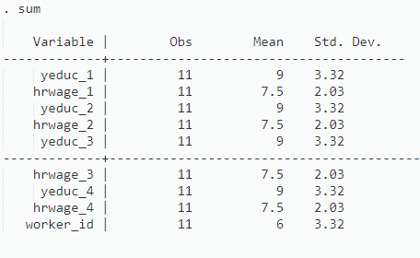

Figure 1: Mean and standard deviation for each variable in dataset ps1q2.dta

* 1. The covariance and correlation between years of education and hourly wages in dataset ps1q2.dta are presented below.

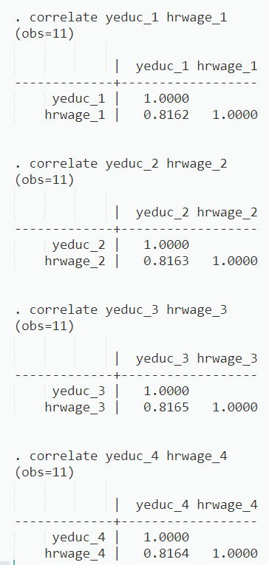

Figure 2: Correlation between years of education and hourly wages in dataset ps1q2.dta



Figure 3: Covariance between years of education and hourly wages in dataset ps1q2.dta

1. For each firm the OLS regress for hourly wages on years of education is below.

*Interpretation: For each firm, the predicted increase on hourly wages for each additional year of education is 50 cents.*

Firm 1 $α_{1}$ = .5

Firm 2 $α_{1}$ = .5

Firm 3 $α_{1}$ = .5

Firm 4 $α_{1}$ = .5

**

**

1. Based on calculations made using the OLS method, for each firm the added value from one year of education is listed below for each firm:
   * 1. Firm 1: 50 cents per hour
     2. Firm 2: 50 cents per hour
     3. Firm 3: 50 cents per hour
     4. Firm 4: 50 cents per hour
2. The relationship between hourly wages and years of education for each firm is graphed below.



Figure 4: Firm 1



Figure 5: Firm 2



Figure 6: Firm 3



Figure 7: Firm 4

1. Reviewing the graphs the prediction is equally good for each firm. This is because the $α_{1}$ value for each is .5, meaning income increases by .50 cents per hour per each additional year of education.
2. Reviewing the graphs the relationship between hourly wages and years of education is/is not the same. This is evident because the graphs all have a unique pattern.
3. Based on points *v* and *vi* above it is suggested that this model is not very useful in predicting wages based on years of education.

# Question 3

1. See appendix I for work

${\hat{β}}_{0}$*= 3.21 –(.383)^2*

${\hat{β}}_{1}$*= 3.21 –(.383)^*

1. The ${\hat{β}}_{0}$ term in this model is/is not useful because any student enrolled has a GPA
2. The GPA score is predicted to be points higher if the ACT score increases by 5 points?
3. The fitted values and residuals for each observation are presented in appendix I.
$$GPA- \overline{{GPA}_{}}= .02$$

$$ACT- \overline{{ACT}_{}}=0$$

4. Blank of the variation in GPA for the eight students is explained by the ACT. This is because…

# Question 4

1. $\overline{beauty }$*= -1.02 e-08, or near zero*

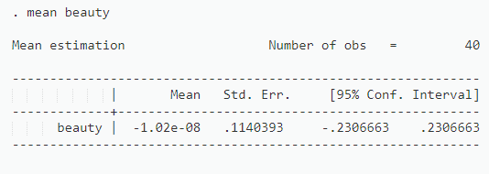

1. ${beauty}_{1}-\overline{beauty }$*=*

*STATA CODE:*

$$beautybar=1.02E8$$

$$generate b1 = beauty- beautybar$$

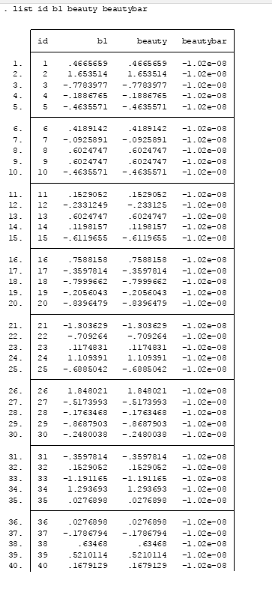

1. The covariance between course evaluation and beauty is .097 rating of instructor/units

**

The units of measure for the covariance between course evaluation and beauty is rating of instructor over units and this does not have a real world interpretation.

1. The correlation between course evaluations and beauty is shown below using STATA and the $P_{x}=\frac{cov(X,Y)}{sd\left(x\right)sd(y)}$



$$p_{x}=\frac{cov(X,Y)}{sd\left(x\right)sd(y}= \frac{.097303}{\left(.721248\right)*(.5986095)}= .225402$$

**

1. The data with beauty plotted on the x-axis is below.



1. Using ${\hat{β}}_{1} =\frac{cov(X,Y)}{var(X)}$ to calculate the regression slope coefficient the value is .279



1. For the data in ps1q4.dta the value of ${\hat{β}}_{0}$ is 4.525 and this does relate to course_eval because it indicates a course evaluation of 4.525 if beauty is zero.

**

1. Using the regression $course_{eval}= β_{0}+ β_{1}*beauty+ u_{i}$

*The OLS estimates is:*

${\hat{β}}_{1}$*= .187*

*compare $β_{1}$ in step vi with $β_{1}$ found in step vi:*

*The step vi estimates is:*

${\hat{β}}_{1}$*= .225*

1. $R^{2}$ is the ratio of the explained variation compared to the total variation and is interpreted as the fraction of the sample variation in Y (dependent variable) that is explained by X (independent variable). For this exact model, in question 4, $R^{2}$ measures how much of the variation in course_evaluation score is explained by beauty. $R^{2}$ is generally multiplied by 100 to change it to a percent.

The standard error (RMSE) of a regression measures the sample standard deviation of the forecast of errors (without any degrees of freedom adjustment)

$R^{2}$ is preferred because it is unitless.

1. $R^{2}$*in step vii is .0508.*

$5\%$*of the variation in course_eval score is predicted by beauty.*

# Appendix I